**Control who can create and manage environments in the Power Platform admin center**

With the new provisioning model, those with the correct licenses can create an environment as long as 1GB of capacity is available. To restrict environment creation and management to admins, do the following:

1. Sign in to the Power Platform admin center at [https://admin.powerplatform.microsoft.com](https://admin.powerplatform.microsoft.com/).
2. Select the **Gear** icon (Gear icon) in the upper-right corner of the Power Platform site.
3. Select **Power Platform settings**.
4. Select **Only specific admins**.

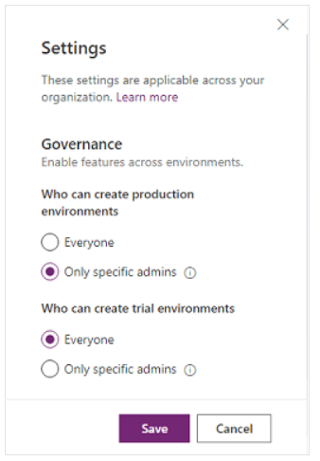

The following admins will be able to create new environments in the Power Platform admin center:

* Global admins
* Dynamics 365 service admins
* Power Platform service admins

## **Control environment creation through PowerShell**

Download and install the admin PowerShell cmdlets as described [here](https://www.powershellgallery.com/packages/Microsoft.PowerApps.Administration.PowerShell/2.0.1). For more information about our cmdlets, see [PowerShell support for Power Apps (preview)](https://docs.microsoft.com/en-us/power-platform/admin/powerapps-powershell).

Use the following commands to restrict environment creation to Global admins, Dynamics 365 service admins, and Power Platform service admins.

*$settings = @{ DisableEnvironmentCreationByNonAdminUsers = $true }*

*Set-TenantSettings $settings*